Senior Non-Commissioned Officer

Command Sergeant Major Ludek Kolesa

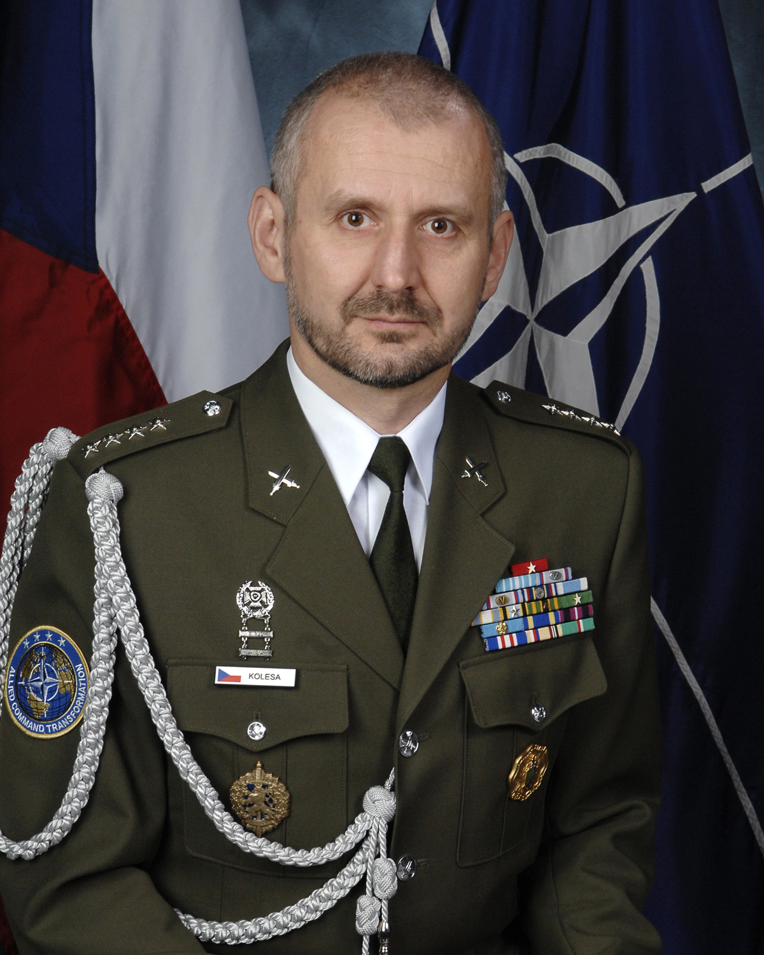
Army of the Czech Republic
North Atlantic Treaty Organization
Ludek Kolesa was born in Litomerice, the Czech Republic on December 14, 1961. During his university years at the Charles University in Prague he completed a two-year course for infantry platoon leaders.
He served as an enlisted soldier from 1985 to 1987 before being employed as a Ministry of Defence (MoD) civilian until 1994. He served a nine-month operational tour during the Balkan wars in the former Yugoslavia, as a member of European Community Monitoring Mission (ECMM).
In April 1994 he re-joined the Army of the Czech Republic as a Private First Class and was deployed with the United Nations Guard Contingent in Iraq (UNGCI) until May 1995. During this period he was appointed Mobile Team Leader and later Operations Officer of Erbil Sector. Kolesa personally led UNGCI teams during two operations rescuing personnel of non-governmental and international organisations in an area of fighting between Kurdish factions in Northern Iraq. Upon his return from Iraq he worked in the Military Observers Office.
From 1995 until 2000 he served at the MoD Foreign Liaison Office as an Executive Assistant to the Director, and later as a Liaison Officer. Between 2000 and 2003 he served at NATO HQ Brussels as an Aide-de-Camp of the Military Representative of the Czech Republic to the NATO Military Committee. During this tour of duty he was elected Secretary, and later President of the NATO Aide-de-Camp Association.
August 1, 2003 he was appointed as the first-ever Sergeant Major of the Armed Forces of the Czech Republic. He then helped design, and presided over, the re-vitalization of his military’s NCO Corps during a period of intense transformation and reform.
Kolesa completed the American Language Course at Defence Language Institute, Lackland AFB, Texas, and then Class 54 of the U.S. Army Sergeants Major Academy in Fort Bliss, Texas. Upon graduation he was awarded the “International Leadership Award” after being named the top international student of Class 54.
In 2007 he was selected as Senior Non-Commissioned Officer, NATO Supreme Allied Command Transformation.
Kolesa was inducted in the U.S. Army Sergeants Major Academy Hall of Honour in May 2008.
Kolesa's awards also include the State of Texas Lone Star Distinguished Service Medal, the Medal For Service Abroad, the Armed Forces of the Czech Republic Medal Grades III, II and I, the UN Special Service Medal, the ECMM Medal, the Slovenian Ministry of Defence Medal for Multinational Cooperation IV Grade, the UNGCI Mission Bar, the U.S. Army NCO Professional Development Award, and The State of Texas Adjutant General's Individual Award.
Current as of May 2010

